- Define the term morphogenesis and then describe when and briefly how cytoplasmic determinants and induction control it.
Morphogenesis can be considered to be a process in which animal try to take their form or shape. Zygote’s genome is the one that is used in the determination of Development and molecules in the cytoplasm egg is what is known as cytoplasmic determinants. The determinants are mainly scattered in unevenly manner in the cytoplasm and this controls the expression of the gene during the differentiation of the cell. Induction mainly sets clear the target cell changes that are mainly as a result of intercellular signaling which is the cell- cell recognition and paracrine signaling. Some of the cytoplasmic determinants includes, organelles, proteins and mRNA.
- Compare and contrast the acrosomal reaction and cortical reactions by defining each and their intended purposes.
The acrosomal reaction is a change in the sperm that is common to many animals. Cortical reaction is mainly an exocytotic process which mainly depend on calcium and in which there is a release of secretary granules into the space known as the perivitellin that occurs immediately after fertilization. Thy mainly act in the prevention of polyspermic fertilization.
The acrosomal reaction and cortical reaction are two different instances. The acro reaction is initiated by the sperm to penetrate the oocyte and the cortical reaction is initiated by the oocyte to prevent polyspermy. It's a good idea to compare and contrast the two, as they do work together, but merging them together is confusing.
- Compare and contrast the developmental stages cleavage, gastruolization, and organogenesis with respect to their definitions, order of appearance, and some basic characteristics.
Cleavage is a process that mainly takes place after fertilization and this mainly involves multicellular organism development. In cleavage, the enormous volume of egg cytoplasm is separated into many smaller and nucleated cells.
During embryonic development the process that mainly alters the embryo to gastrula which has different cell layers from blastula which has a cell layer which is single is what is mainly known as the Gastrulation process and mainly involves the folding of blastula in upon itself or dividing and these brings about creation of two cell layers. Here the cells are normally reorganized into a three layered gastrula.
Organogenesis is among the embryonic development phase that mainly commences when the gastrulation ends. This goes on until the time birth takes place. There are mainly three layers which are created during organogenesis and this includes mesoderm, endoderm and ectoderm. This mainly form the organism internal organs. Ectoderm mainly comes up with tissues and epithelial cell and they are commonly known as neuronal tissues. The organs in this is as a result of the interaction between the three germ layers.
4. Describe the experiment How does distribution of the gray crescent affect the development potential of the two daughter cells? (please, feel free to use a description of the experiment detailed on slide 33 as part of your answer)
There is formation of Body axes immediately when the sperm enters the egg. This brings about A dorsal ventral-back belly axis and thus brings about and existence of a region known as a gray crescent. The gray crescent then changes into Spemann’s organizer, this mainly act as a signaling center that mainly inform other tissues of direct development. Transplantation of an extra organizer into a newt embryo results in two newts joined at the belly! A good example of induction can be taken to be signalizing by Spemann’s organizer a process through which one tissue sends signals to change the development of another.

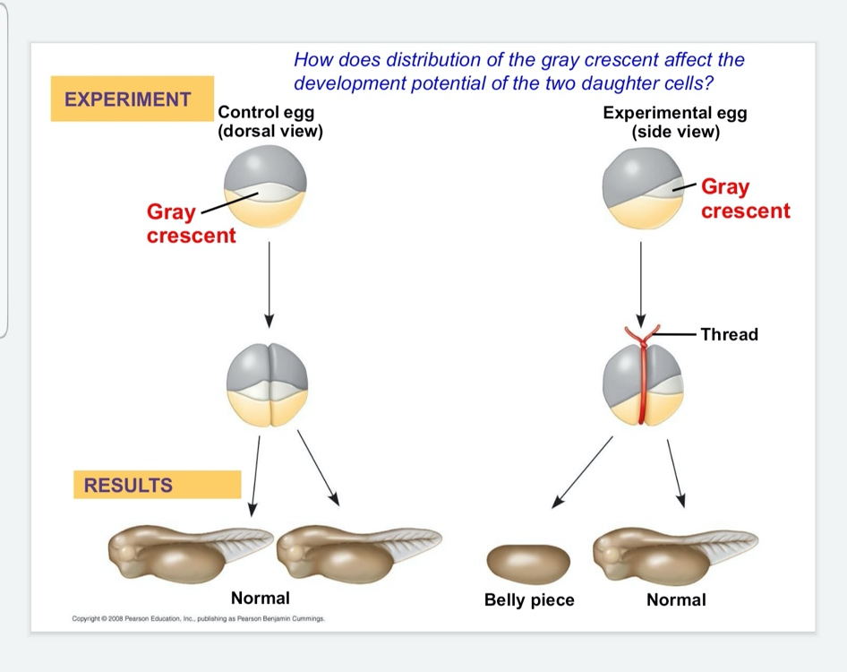

1. What is ovulation? *

A. The release of a mature egg cell
B. The loss of the lining of the uterus
C. The joining of a male sex cell and a female sex cell
D. The collapse of the corpus luteum.

2. Implantation of the human zygote in the uterine lining takes place after which of the following? *

a. Some months
b. Month
c. 7-10 days
d. 3 weeks

3. Which of the following do not have any function in placental mammals? *

A. Yolk sac
B. Amnion
C. Allantois
D. Chorion
4. Fertilization of ovum occurs in which of the following? *

A. Uterus
B. Vagina
C. Cervix
D. Fallopian tube

5. Sperm production is directly regulated by which of the following? *

A. FSH and LH
B. Estrogen and GnRH
C. Testosterone and FSH
D. Testosterone and LH

6. Offspring that are produced by asexual reproduction are called which of the following? *

A. Gametes
B. Zygotes
C. Clones
D. Haploids

7. Which of the following is best described by the term an “r species”? *

A. A mother polar bear with her two cubs
B. A blonde woman at the mall buying shoes for her six kids
C. A dog nursing her 8 puppies
D. An fence lizard burying her eggs in a sand hill

8. Which of the following cell types are directly responsible for the production of testosterone? *

A. Leydig cells
B. Sertoli cells
C. Hibin cells
D. Follicle cells

9. At what point during the human menstrual cycle is progesterone production the highest? *

A. Ovulation
B. Follicle maturation
C. The sloughing of the endometrium
D. The thickening of the endometrium

10. Which of the following terms best describes the offspring of a female lizard without fertilization by a male? *

A. Sporulation
B. Hermaphroditism
C. Parthenogenesis
D. Amphiogenesis

